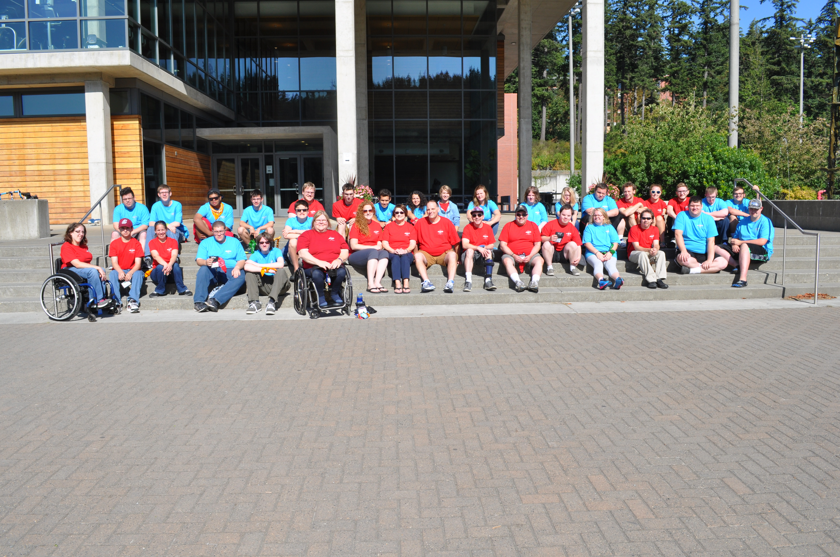
We are looking for future community leaders!!

Come join us for the 18th Youth Leadership Forum for High School Students with Disabilities, an exciting, fun, educational, five-night, six-day,
Leadership Program!!

The Youth Leadership Forum is a project of the Washington State Governor’s Committee on Disability Issues and Employment

Deadline to apply: June 8, 2018

WHO: Approximately 35-50 high school students with a disability will be selected to attend the Forum.

WHEN: July 22 – 27, 2018

WHERE: The Evergreen State College,
Olympia, Washington

COST: Students/Parents will not be charged the cost of a student to attend this Forum.
Please fill out this application, save and then email/scan it to estefanowicz@esd.wa.gov

- Students must complete all information on pages 1– 7 of this application. (If you need help, please ask your parents or teachers or you call Elaine Stefanowicz at (360) 902-9362.

- Email/Scan the completed application to the email address above.

- If you would like this application in another format, contact Elaine.

YLF Application, Page 1

Youth Leadership Forum Application
Due Date – June 8, 2018

(This application is a Word document and can be filled out by tabbing to each highlighted box. The boxes will expand to the inputted content.)

- Student’s Name:
- Gender: Date of Birth:
- Mailing Address:
City, State & Zip Code:
Email Address:
- Home Phone Number:
Cell Number:
Parent’s Email Address:
- Name of High School:
Phone #:
- Are you receiving Transition Services from the Division of Vocational Rehabilitation (DVR) or Department of Services for the Blind (DSB)? Yes No

- Grade Level on July 1, 2018 (must be a junior, senior or 2018 graduate or still receiving services from your school district):

- High School Graduation Date:
YLF Application, Page 2

Student’s Name:

- School and Community Involvement:
Please list any extra-curricular involvement with your school and community. (This may include offices you have held, club memberships, after school activities or work experiences.)

School-related extracurricular activities:
*Activity:
Grade Level: Dates:

*Activity:
Grade Level: Dates:

*Activity:
Grade Level: Dates:

Community-based extracurricular activities:
*Activity:
Grade Level: Dates:

*Activity:
Grade Level: Dates:

*Activity:
Grade Level: Dates:
YLF Application, Page 3

Student’s Name:

- Recommendation:

- High School Representative (teacher, principal, counselor, coach).

Name:
Title:
Organization:
Phone:
Email:

- Community Representative (employer, friend, pastor, etc.).

Name:
Title:
Organization:
Phone:
Email:

- Survey of Personal Interest

Your answers to the following topics will be used to assess your interest and readiness to participate in the Youth Leadership Forum. Please type your responses to the topics in the section(s) (a-d).

YLF Application, Page 4

Student’s Name:
Tell us more about yourself (the text box will expand based on the information).

- Experiences as a person with a disability –What are two important experiences (good or bad) you have had as a young person with a disability? (Please be specific about your examples as they relate to your disability.)

(b) In terms of leadership, please tell us about two people who have positively influenced your life and why. (Family members, teachers, counselors, friends, public officials or celebrities are appropriate examples.)

- Why do you feel you are qualified to be a delegate to this Youth Leadership Forum and please tell us why you want to participate?

- Describe your future plans after high school graduation.

YLF Application, Page 5

Student’s Name:

12. **Your answers to the following will not deny you from participation in the Forum. Please answer the following comment that corresponds to the statement.

Other Information:

- Student is able to maintain their personal hygiene (shower/bath, brush teeth and toilet).

Needs assistance with personal hygiene.
Needs reminders to complete personal hygiene.
Independent and ready for routine scheduled events.

- Student is independently ready for routine scheduled events (activities, meals, etc.).

Needs assistance with routine scheduled events.
Needs reminders to complete routine scheduled events.
Independent and ready for routine scheduled events.

c. Student responds appropriately to personal safety and emergencies (alarms, weather, etc.).

Needs assistance to maintain personal safety.
Needs reminders to maintain personal safety.
Responds appropriately to personal safety & emergencies.

YLF Application, Page 6

Student’s Name:

I have completed the Youth Leadership Forum Application and understand that I will be contacted regarding my attendance by June 13, 2018.

13.
Signature of Student Date

14.
Signature of Parent/Guardian Date
Parent Phone:
Parent Email:

(If signatures are electronic, please provide the phone/email of a parent if you are under the age of 18.)

(Students 18 or older and on your own, don’t need to have the signature of a parent/guardian.)

T-Shirt Size (need to place the order early)
X-Small
Small
Medium
Large
X-Large
XX-Large
XXX-Large

YLF Application, Page 7

Student’s Name:

(Keep this page for Your Records, DO NOT RETURN)

Please use the checklist below to make certain your application packet is complete. Incomplete applications will not be considered.

Checklist Completed
1. Application form (9 pages)
2. Signed application (Student & Parent/Guardian)
3. Survey of Personal Interest (response to 4 topics)
4. Photocopy application for your records
5. Photo of Student

15. Please Email/US Mail or FAX the application to the address below.

Governor’s Committee on Disability Issues & Employment
Elaine Stefanowicz
PO Box 9046
Olympia, Washington 98507-9046

Email: estefanowicz@esd.wa.gov

(360) 902-9362
(360) 586-4600 FAX

If you have any questions, please contact Elaine Stefanowicz at the above number/email.

Applications must be emailed/postmarked by
June 8, 2018 for consideration!!

Thank you for completing this application!

